SCHOOL INTERVIEW/DISCUSSION GUIDE

Name of school: WARAISA SEED SECONDARY SCHOOL

1a | Does the Facility have a record of all assets provided under UgIFT.  (Obtain a record and verify if it has the costs and numbers supplied | - No they didn’t.
1b | If Not ask how many were supplied and when. | - The supplier supplied once and didn’t return to install.

2 | How does this facility Maintain (repair/service/replace) the assets provided under Ugift.  - Through the capitation grant the facility only maintains minor repair, services and replacement. For example they fix broken furniture and also replace or buy more new ones.  However, the contractor is still maintaining the facility until the agreed period is done.

3 | Does the facility take regular record about functionality/ or breakdown of the assets provided?  Nonfunctional/ working, and reasons for non-functionality. | Yes  REASONS FOR NON FUNCTIONALITY  - Lack of electricity. The facility is not connected to the national grid therefore the absence of electricity is hindering administrative work, practical science lessons, security at night and installation of ICT items in the lab

4 | How has the UgIFT support helped in service delivery in the area, any issues, challenges and any recommendations for better program implementation. | ISSUES  - Critical staff shortage. The institution has lost 2 science teachers i.e biology, chemistry , ICT , who were degree holders, this has created a significant gab and the school is currently under staffed hence affecting effective teaching and learning  - Commissioning of the school. Since establishment, the school has never been officially commissioned since last year 14th/july up to date no feedback and this is affecting the facility and thus causing low enrollment at the school’  - Lack of clean water supply. The school water source is salty and not fit human consumption. Therefor e the school is incurring and extra cost to collect clean water from distant water sources.  - Inadequate furniture. The school desks are grossly inadequate to currently cover the 464 learners yet the facility received 129 desks thus making it difficult to sit comfortably during lessons.  - Inadequate science laboratory equipment. The school is having a challenge of lack of lab equipment such as , retort stands(only 5 available against the 83 enrolled students), meter ruler. This is affecting the hands on the competency based curriculum.  - Incomplete acknowledgement of deliveries. The school did not sign anywhere for some of the items reported as received. Only partial delivery has been done and records are not clear. For instance in some cases only 1 item was received against what was indicated.  i.e the installation of computers has not been done because the promise to come back with the remaining items to install everything at once but he has not returned since and “IT IS NOW A YEAR”  - Lack of text books for CBC. The school lacks adequate text books for the new competency based curriculum. Forinstance teachers and learners do not have enough instructional materials thus affecting the effective implementation of the system.  .  RECOMMENDATIONS  - We request the ministry through the district service commission to urgently recruit and post more teaches at the facility especially the .biology and ICT teacher to fill in the gap.  - On commissioning. We request the relevant authorities to expedite the commissioning process of the school to enable it access full government support and recognition.  - On lack of electricity. We appeal for the connection of the school to the national power grid too support learning and security.

PROCEED TO VERIFICATION AFTER THIS DISCUSSION

SCHOOL FURNITURE
(School Desks, Office chairs, Laboratory stools, Book shelves)

Name of LG mayuge district local government Name of SCHOOL: WARAISA SEED SECONDARY SCHOOL

Equipment/ Item | Department | Asset Number | Item  Description | Life in Months | Tag Number ( engrave no.) | Date Of Pur | Date Placed In Service | Recoverable cost | Cost | Acc Dep Cost | Net Book Value | Ytd Deprn | Equipment status | Remarks
School Desks | education |  | Long Brown wooden with grey metallic stands and a shelve for books a]] |  | Engraved  (WAIRASA S.S) |  |  |  | 3,000,000 |  |  |  | Good  And  functional | 72 desks verified and 1 damaged
Office chairs |  |  |  |  |  |  |  |  |  |  |  |  |  | Not received
Laboratory stools | education |  | Round woolen stool with 4 grey metallic stands |  | Engraved  (WAIRASA S.S LAB) |  |  |  |  |  |  |  | Good and  functioning | 114 verified and in use.  3 damaged
Learners chairs | education |  | Brown wooden chairs with hard sits and 4 grey metallic stands |  | Engraved  (WAIRASA S.S) |  |  |  | 2,688,000 |  |  |  | Functional  And in use | 266 verified and all in use
Book shelves | education |  | Grey metallic with wooden partitions standing vertically on the wall |  | Not engraved |  |  |  |  |  |  |  | Good and  functional | 46 verified and all in use
walldrops | education |  | Vertically mounted brown Wooden walldrops |  | Not engraved |  |  |  |  |  |  |  | Good and  functional | 8 verified
Office table | education |  | Wooden brown table with wadrops and metallic stands grey in color |  | Not engraved |  |  |  |  |  |  |  | Functional  And In good  condition | 6 verified and  in use
Learners table | education |  | Brown wooden tables with grey metallic stand |  | Not engraved |  |  |  |  |  |  |  | functional | 70 verified
Staff room and laboratory cabins | education |  | Brown wooden small  cabins mounted on the wall |  | Not engraved |  |  |  |  |  |  |  | Functional  And all  In use | 91 verified

ICT ITEMS TO VERIFY
(Desktop Computer, Server Processor, Network Switch 24 Port, Multipurpose Printer, UPS, Projector, Air Conditioners, Server, CCTV Camera)

Name of LG : MAYUGE DISTRICT of SCHOOL : WAIRASA SEED

Equipment/ Item | Department | Asset Number | Item  Description | Life in Months | Tag Number ( engrave no.) | Date Of Pur | Date Placed In Service | Recoverable cost | Cost | Acc Dep Cost | Net Book Value | Ytd Deprn | Equipment status | Remarks
Desktop Computer | education |  | Black in color,  Dell, model  1012841571  of 2024, 26th  December.  512Gb SSD  8GB DDR |  | Not engraved | 9th-04-2025 |  |  |  |  |  |  | Good and  functional | 7 boxes stored  and verified.  4 in use and verifies
Server Processor |  |  |  |  |  | 9th-04-2025 |  |  |  |  |  |  |  | Not received  and not  verified
Projector | education |  | Very long in  a box |  | Not engraved | 9th-04-2025 |  |  |  |  |  |  | Good and  functional | One box  verified  and  And in store
Multipurpose Printer | Education |  | Laser jet  printer  HP=mfp3103fd  w |  | Not engraved | 9th-04-2025 |  |  |  |  |  |  | Good and  Functional  But kept | 1 box  Verified  And in store
KIeyboard | Education |  | It is a model  KB216t1 |  | Not engraved | 9th-04-2025 |  |  |  |  |  |  | Good and  functional | 7 in store  in (boxes)  4 in use
Air Conditioners, | Education |  | AS-18CR  4SMSCAO4 |  | Not engraved | 9th-04-2025 |  |  |  |  |  |  | Functional | 2 boxes in  store
UPS |  |  | LWUPS100 |  |  | 9th-04-2025 |  |  |  |  |  |  | Good and  functional | 5 boxes  Verified and  Kept in store
CCTV Camera) | Education |  | Model  DS-2CD1143G2-4U |  |  | 9th-04-2025 |  |  |  |  |  |  | Good and  functioning | 1 box and not  Installed rather  Kept in store
Network Switch 24 Port | education |  |  |  |  | 9th-04-2025 |  |  |  |  |  |  |  | Not received  Not verified
Server | education |  |  |  |  | 9th-04-2025 |  |  |  |  |  |  |  | Not received  Not verified

BUILDINGS TO VERIFY
(Non- Residential and Residential, Kitchen, Toilets/Pit latrine Water tanks, Fences etc.)

Name of LG : MAYUGE DISTRICT Name of SCHOOL : WAIRASA SEED

Equipment/ Item | Department | Asset Number | Item  Description | Life in Months | Tag Number ( engrave no.) | Date Of Pur | Date Placed In Service | Recoverable cost | Cost | Acc Dep Cost | Net Book Value | Ytd Deprn | Equipment status | Remarks
Staff quarters | education |  | Brown and yellow painted blocks with  4 bedrooms each |  | Not engraved |  | 19-Oct-2022 |  |  |  |  |  | Good and  functional | 3 blocks verified
kitchen | education |  | Painted  Brown and  yellow |  | Not engraved |  | 19-Oct-2022 |  |  |  |  |  | Good and  functional | 3 blocks verified
Water tanks | education |  | Black in color |  |  |  | 19-Oct-2022 |  |  |  |  |  | Good and  functional | Verified 1 for the staff  and 2 for the school
latrines | education |  | Painted  Brown and  yellow |  | Engraved  Male and female |  | 19-Oct-2022 |  |  |  |  |  | Functional and in use | 3 for the school(with 4 stances and 1 PWS).  2 for the staff quarter  (With 2 stances and non for the pws)
blocks | education |  | Painted  Brown and  yellow |  | Engraved |  | 19-Oct-2022 |  |  |  |  |  |  | 7 blocks verified  With 6 classrooms,  1main hall  1 library  1 science lab  1 admin block
Lightening conductor | education |  | Placed on the roof of the blocks,  Metallic in color,  Protruding to the groung |  |  |  |  |  |  |  |  |  | Good and working | 10 verified
fence | education |  | Wired mesh fence surrounding the school premises  And brick built gate(main entrance) painted brown and yellow |  |  |  | 17th/june/2025 |  |  |  |  |  | functioning | Verified and physically present

ASSET VERIFICATION BRIEF REPORT

FACILITY : WAIRASA SSS,

CONDUCTED BY

WANDERA SOLOMON AND KIYUBA SALIMU

Introduction.

This brief report presents the findings of the physical asset verification exercise conducted at WAIRASA SSS . The team was warmly welcomed by the respondent, (Deputy Head Teacher Wairasa sss) who was the focal person in this exercise (

Findings.
- Key assets including , furniture and buildings were physically verified and found present. However, those that were not physically verified were not received i.e. .The Air conditioner
- All the items were found to be functional and in good physical condition. However, it was observed that some of the equipment are currently stored and not yet in active use e.g CCTV Cameras, projector, some desktops, some UPS, and others. This is due to lack of installing professionals. Despite being stored, the equipment handling was good. i.e., we observed that the uninstalled equipements are kept inside boxes to prevent them from dust.

Challenges.
- Some assets were not engraved thus making the verification exercise very hard because we could not establish whether some equipment that we were verifying were for UGift Or not.
- No fence
- The facility has inadequate accommodation for staff
- The the installation of computers has not been done because the promise to come back with the remaining items to install everything at once but he has not returned since and “IT IS NOW A YEAR”
- The facility has no pitch to conduct the new CBC

Recommendation.

Construct additional staff quarters to accommodate and retain critical staff
- Provide a water source .

- Installing the still boxed equipements like CCTV Camera

Conclusion.
- The asset verification exercise was successfully completed . All critical assets were verified, are functional, in good condition and well-handled though a few were not yet installed
- . Addressing the lack of pitch issue, providing a water source at the wairasa sss and installing the boxed equipements are the two high priority challenges and if addressed, they will greatly improve service delivery and asset management at Wairasa sss.

WAIRASA SEED SECONDARY SCHOOL

PhysicalVerification Pictures.

The table below illustrates some physical status of the verified assets with photographic evidence for WAIRASA SEED SECONDARY SCHOOL

Physical verification photos

WAIRASA SSS SIGN POST | 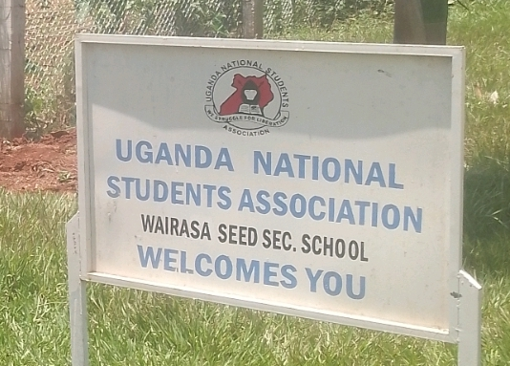
ADMINISTRATION BLOCK WITH TWO UNITS | 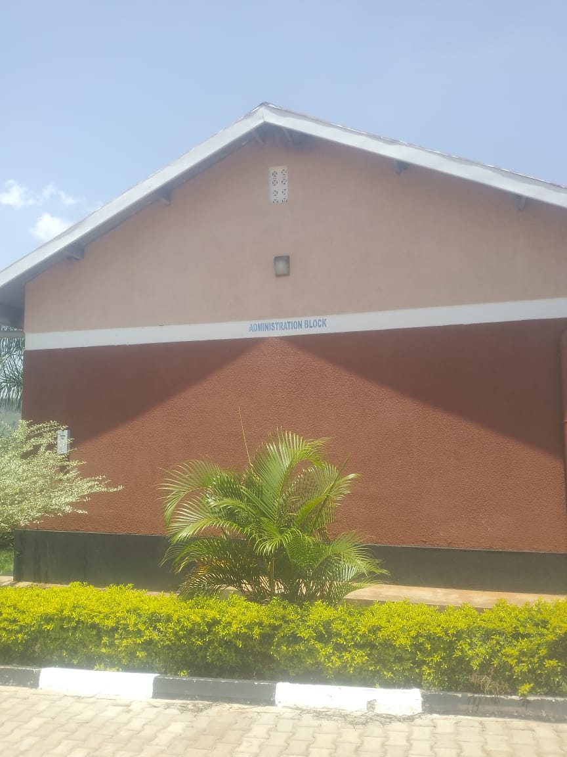
ICT /LIBRARY BLOCK ON THE LEFT AND THE LIBRARY ON THE OTHER RIGHT SIDE | 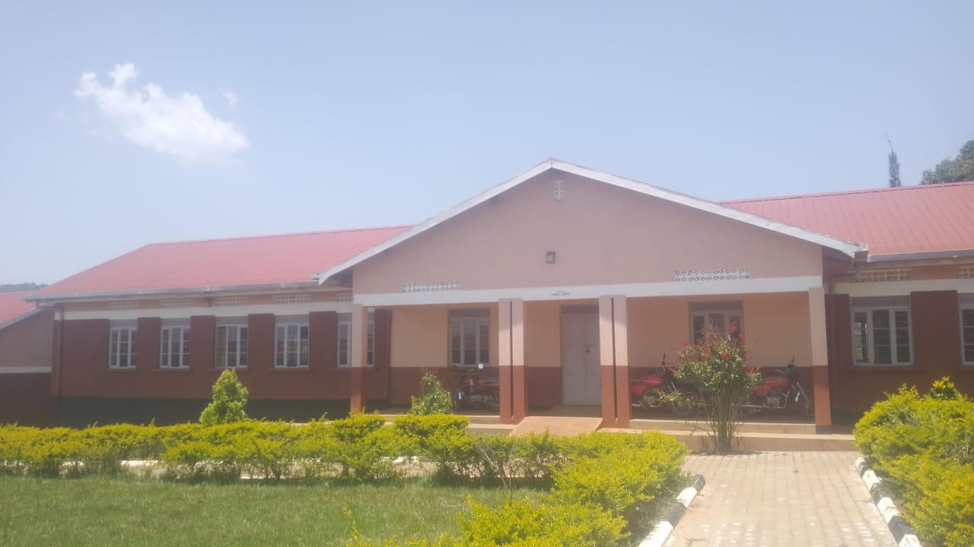
TYPICAL TWO UNITS CLASSROOM BLOCK | 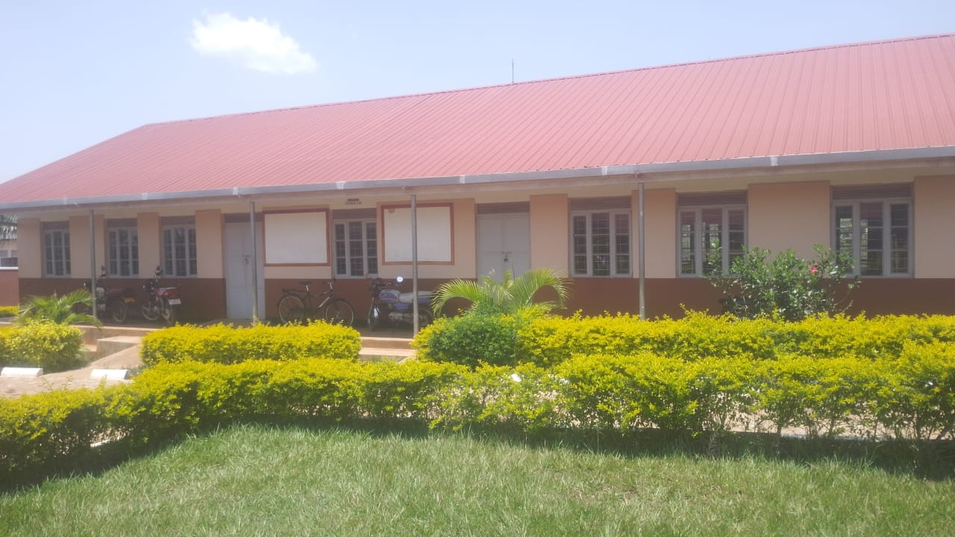
5,000LTRS HDPE CREST TANK WHICH FEEDS A 3,00OLTRS ELEVATED HDPE TANK WITH A PUMP | 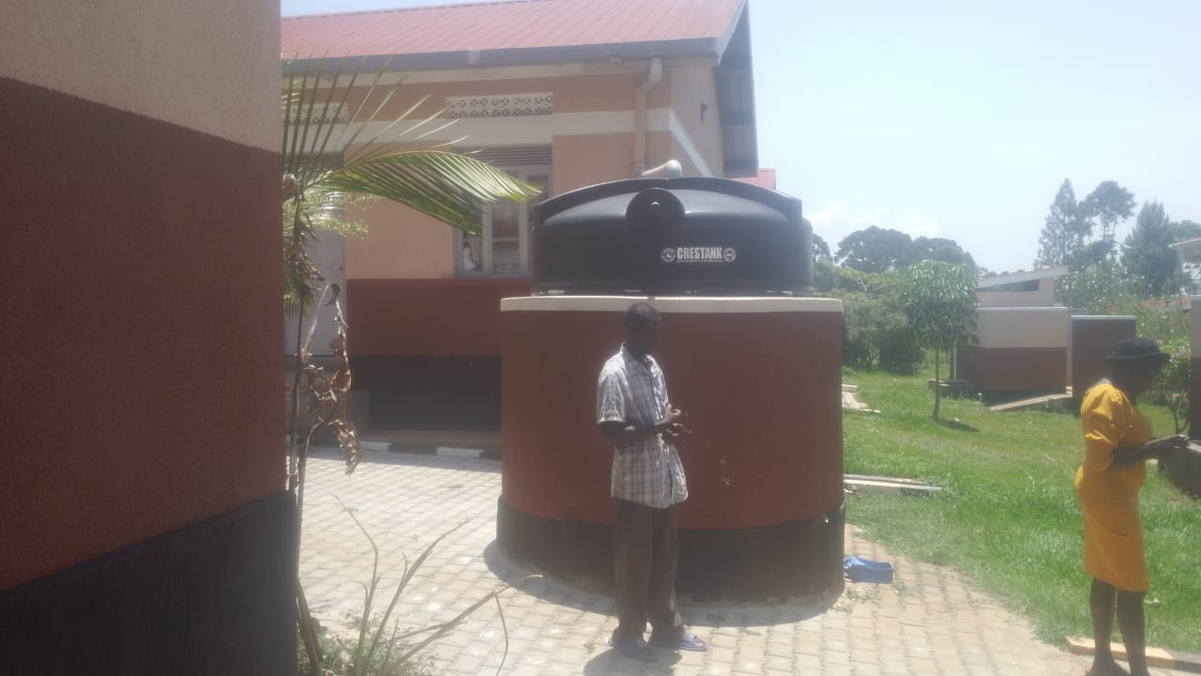
WALL LABORATORY TABLE WITH SHUTTERS, AND SINKS AND WATER CONNECTION | 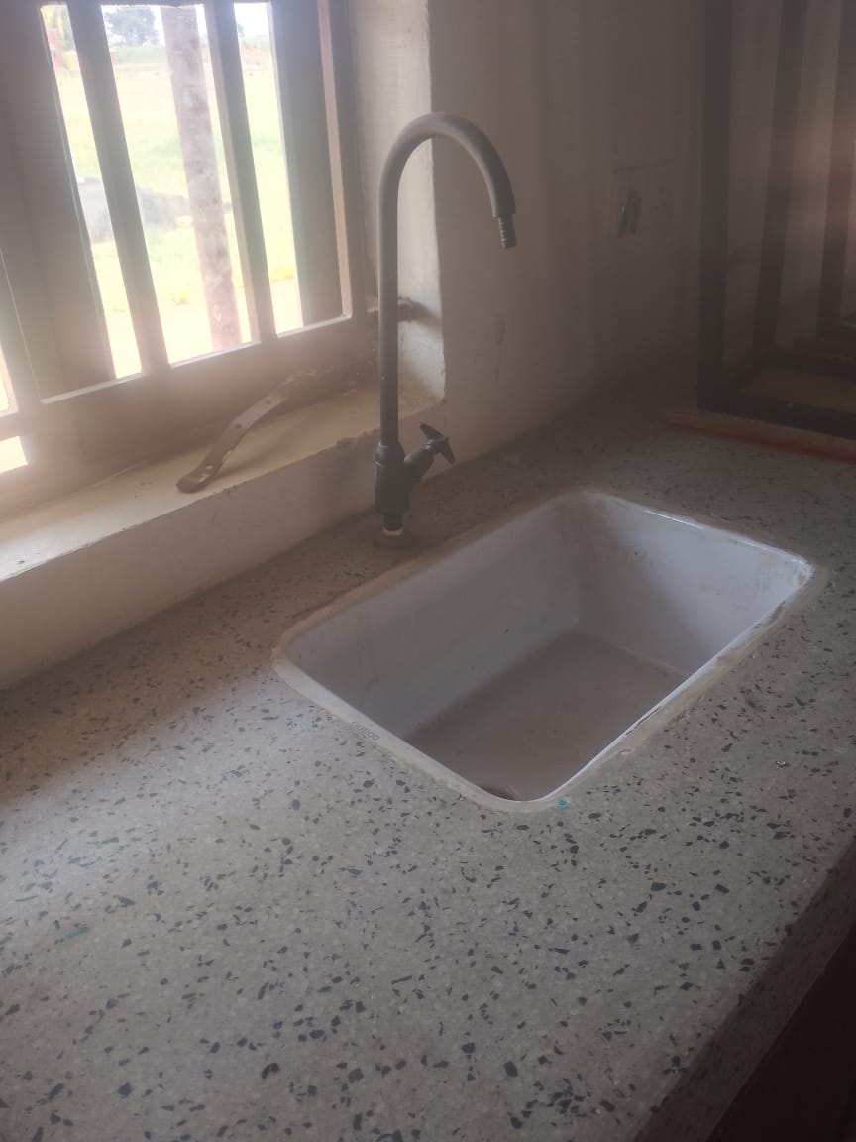
 | 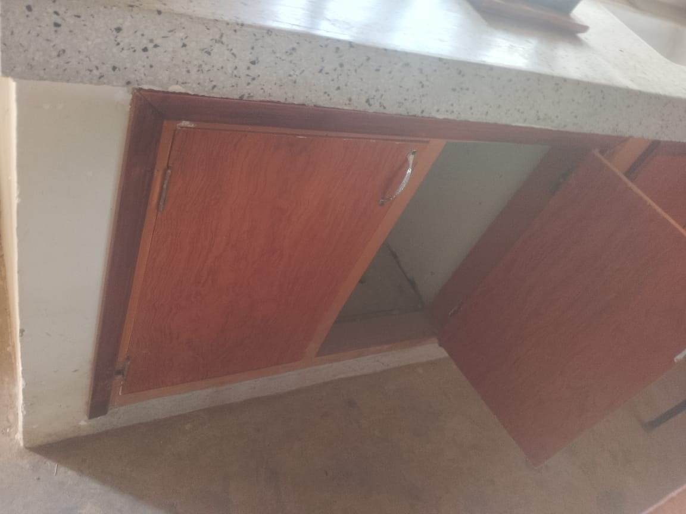
A SAMPLE OF THE 3 BUILDINGS STAFF QUARTER.  WITH 2 ROOMS ON EACH BUILDING | 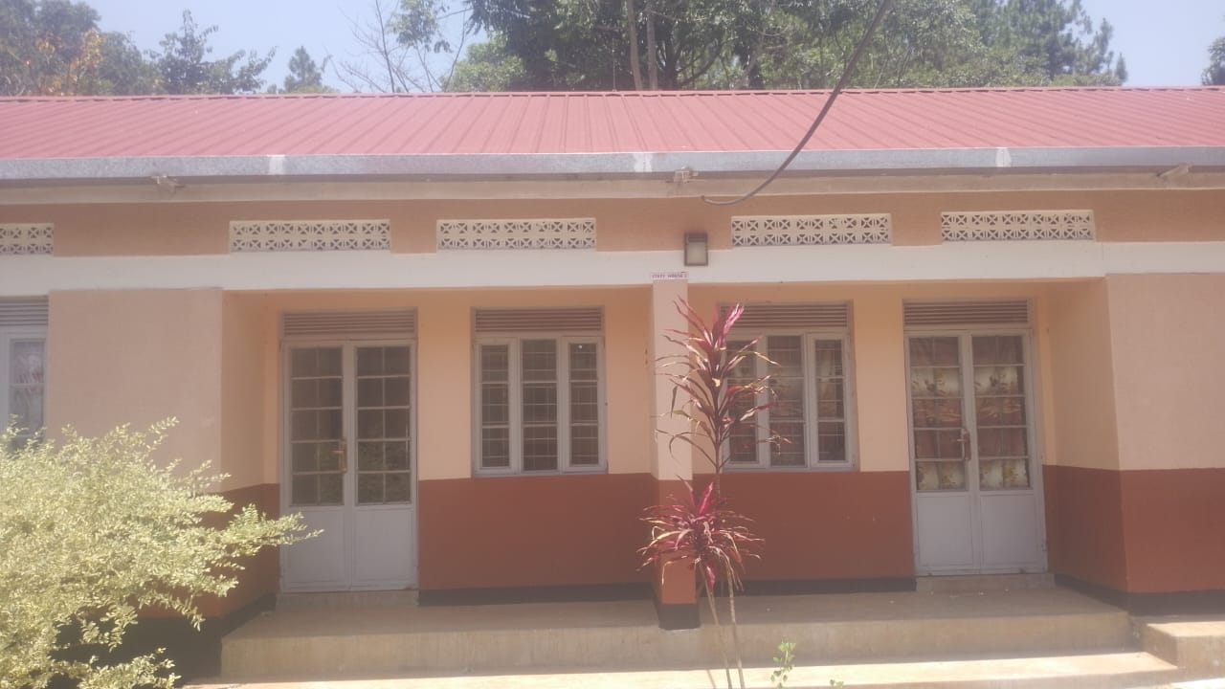
STAFF QUARTER TOILETS(WITH 2 STANCES) | 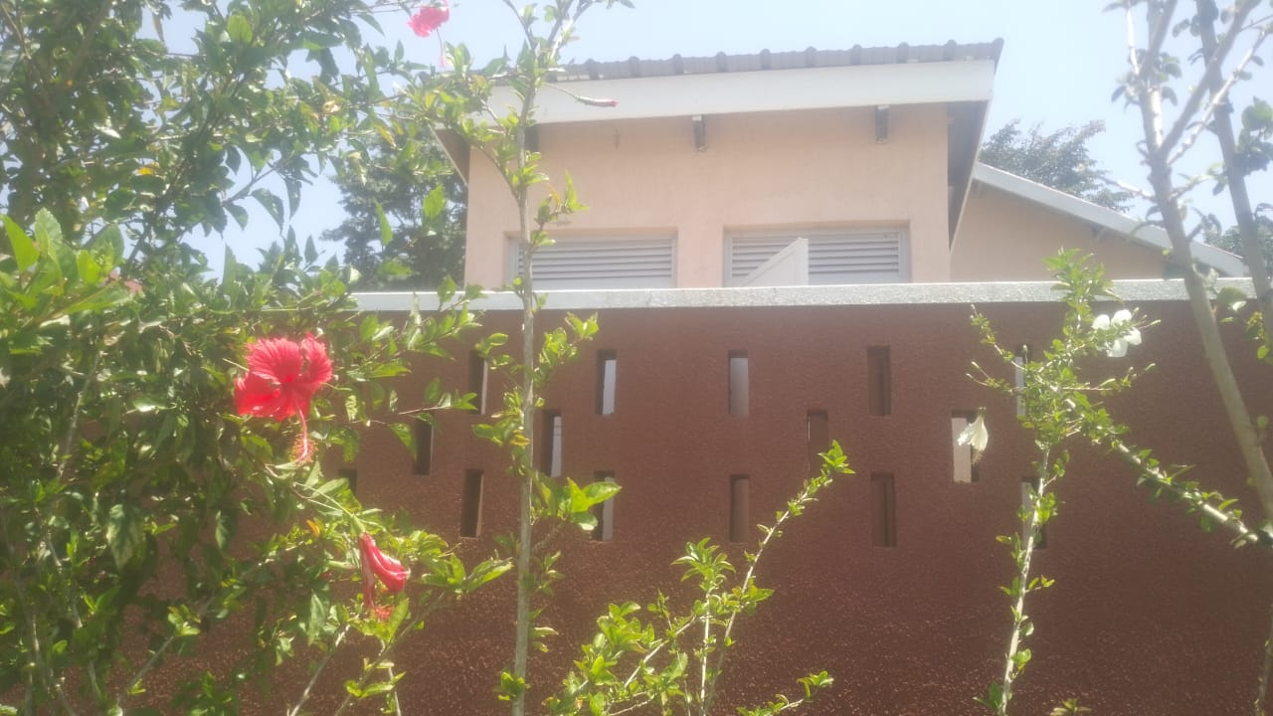
TYPICAL 4 STANCE PIT LATRINE BLOCK | 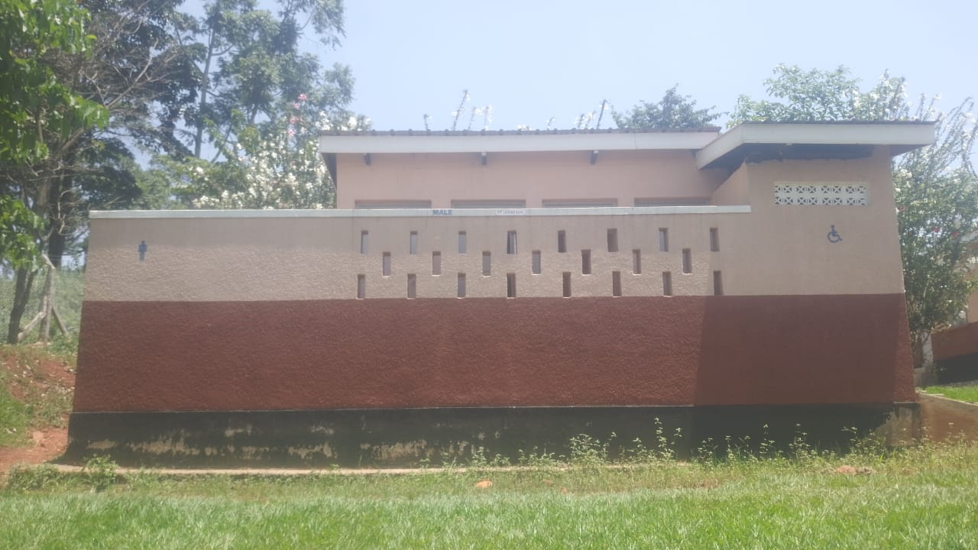
BOXED PROJECTOR (NOT IN USE) | 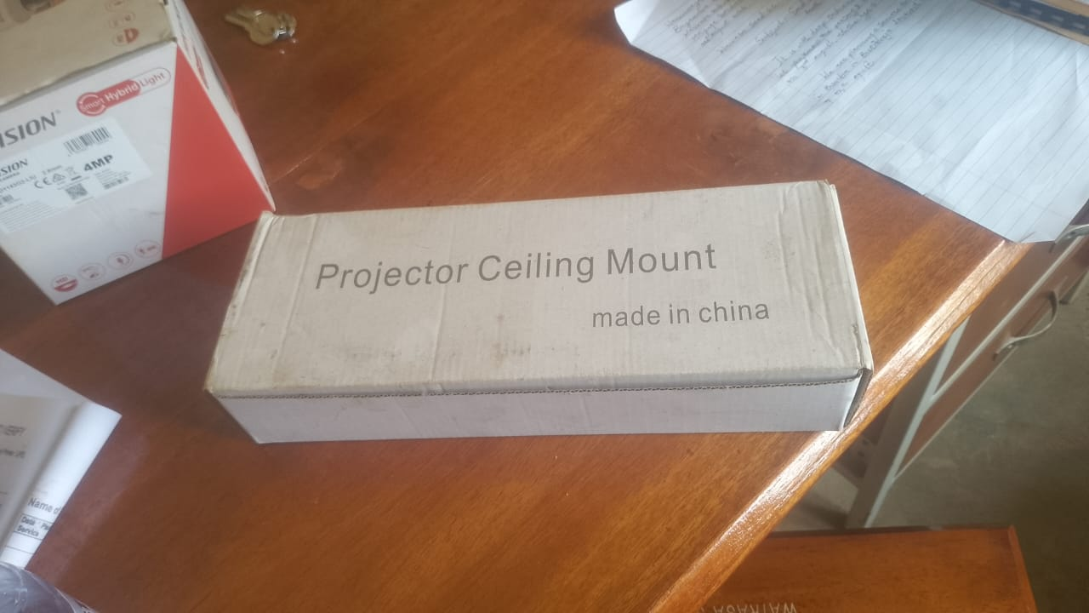
CCTV CAMERAS  (BOXED AND NOT INSTALLED) | 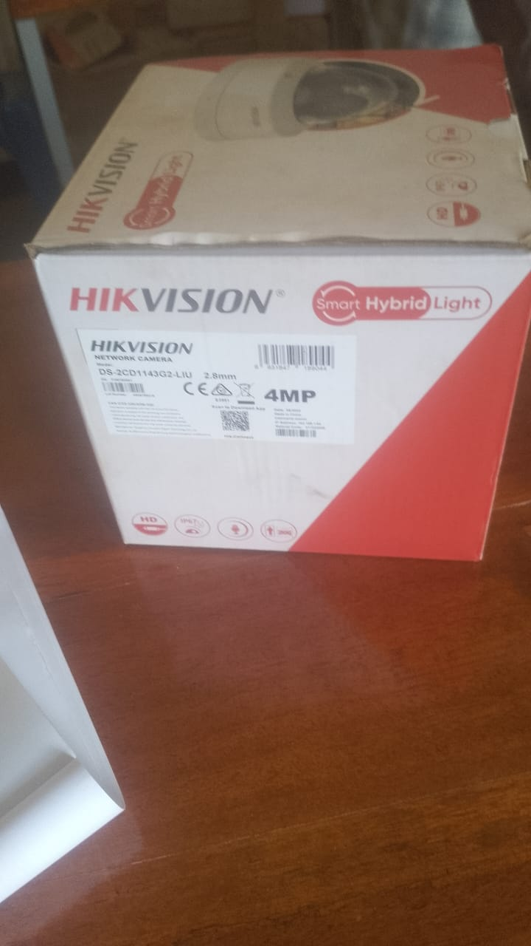
UPS ( BOXED AND NOT INSTALLED) | 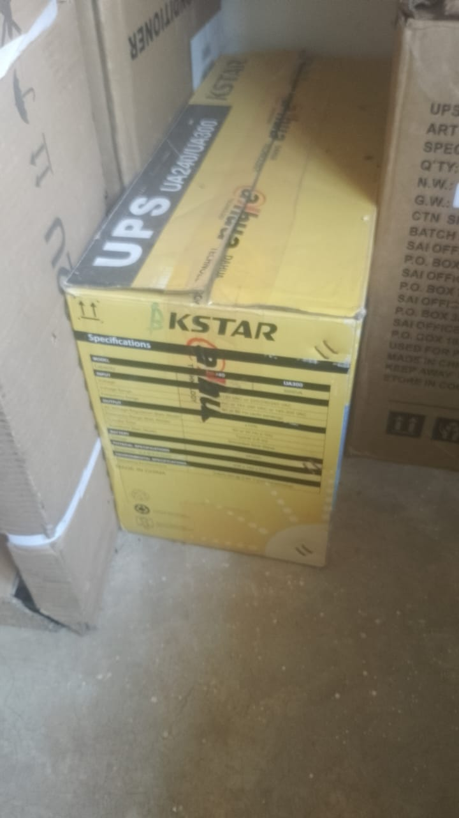
UNBOXED DESKTOPS  (DELL VOSTRO 3030, CORE i5, 8GB) | 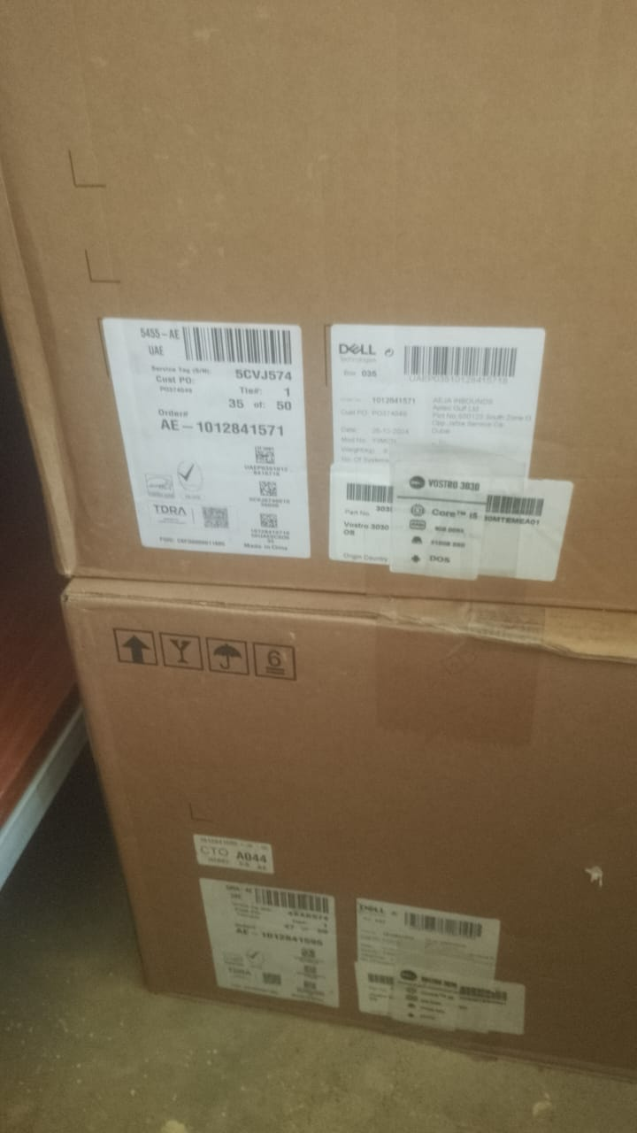
COMPUTER SET AND MONITOR | 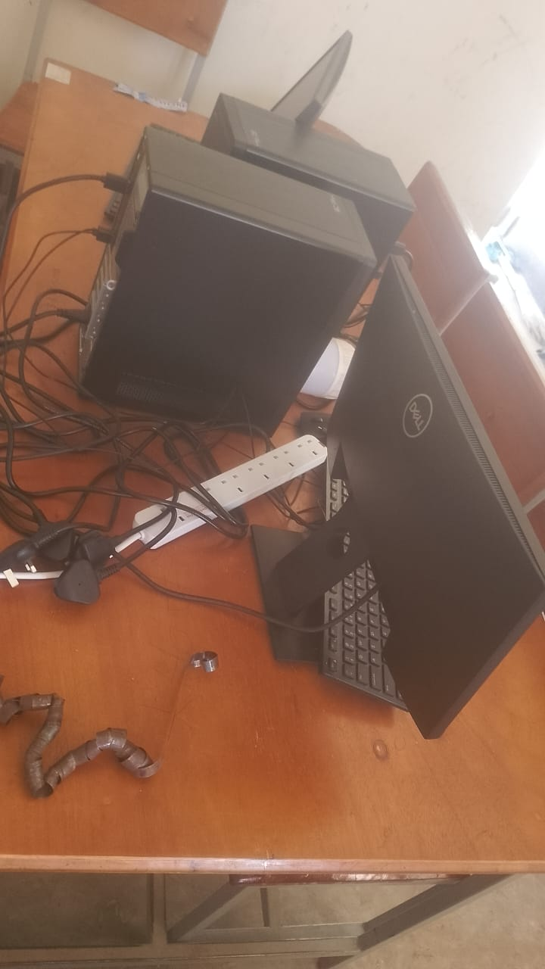
A SAMPLE OF WALL MOUNTED SOFTBOARDS.(2 IN EACH CLASS AND 2 OUTSIDE SOME CLASSROOMS | 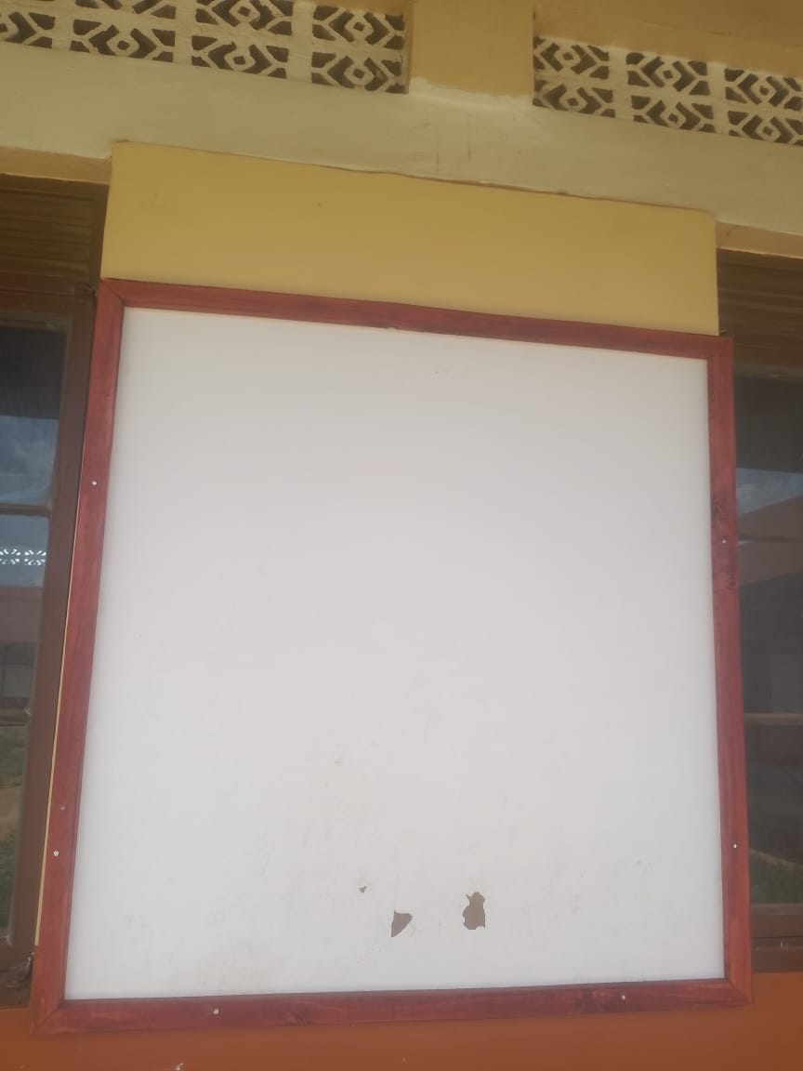
ENGRAVEMENT FORMAT SAMPLE OF DESKS | 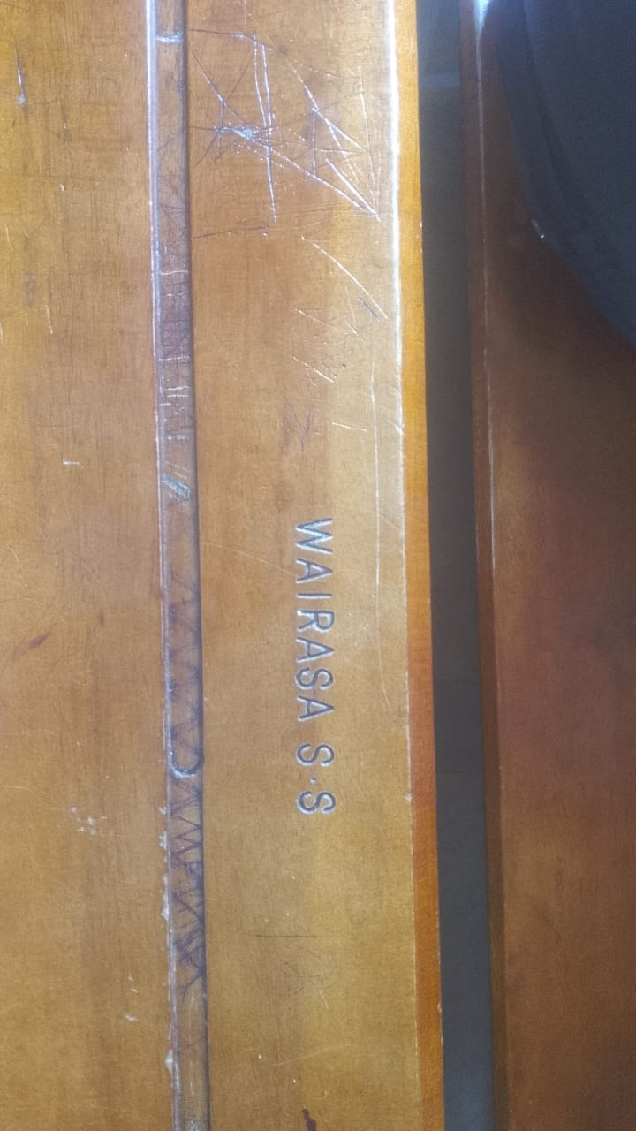
 | 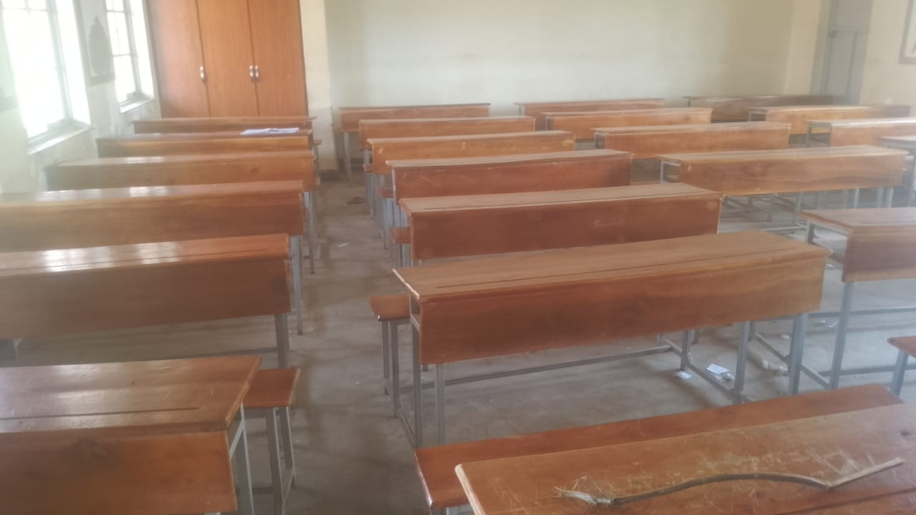
ENGRAVEMENT SAMPLE FOR THE LAB STOOLS  ENGRAVED “WAIRASA SS LAB” | 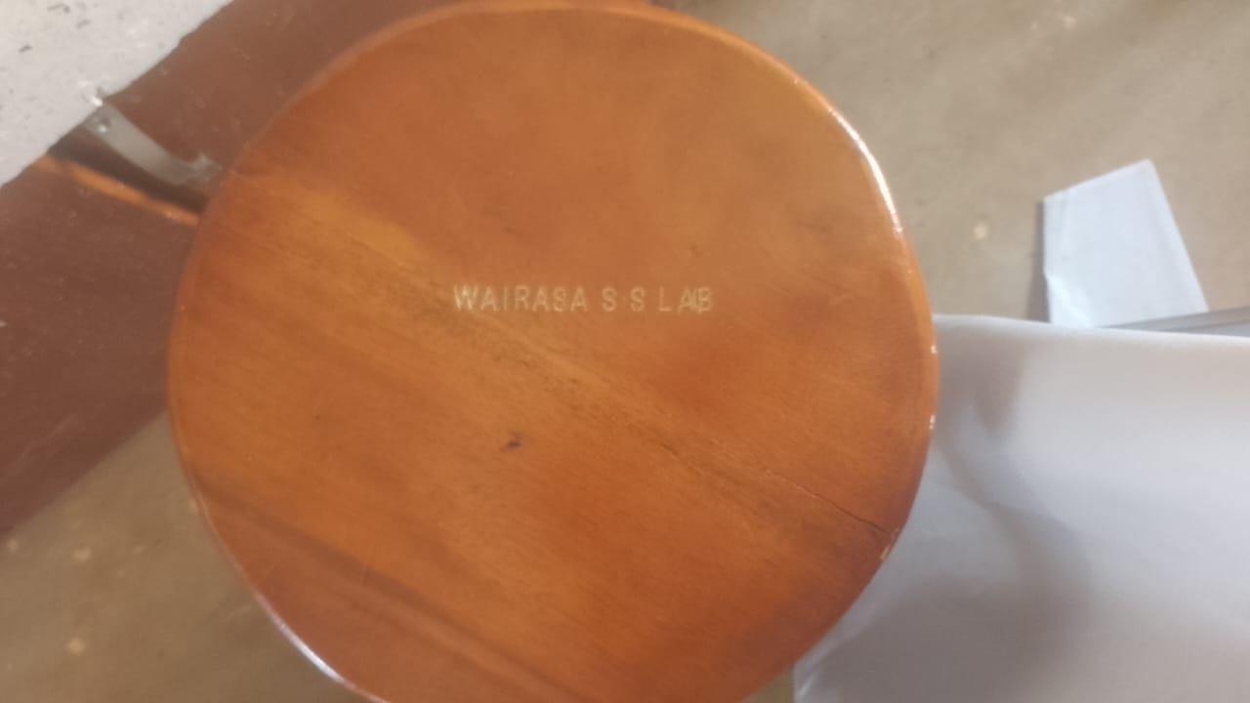
SAMPLE OF CHAIRS, ALL ENGRAVED “WAIRASA SS” | 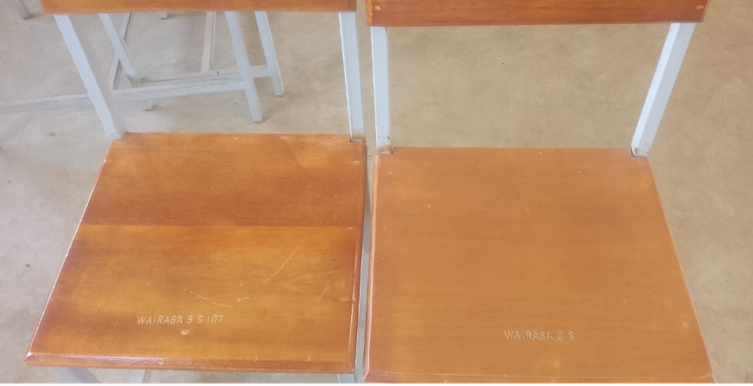
UNENGRAVED CLASSROOM BOOK SHELVES | 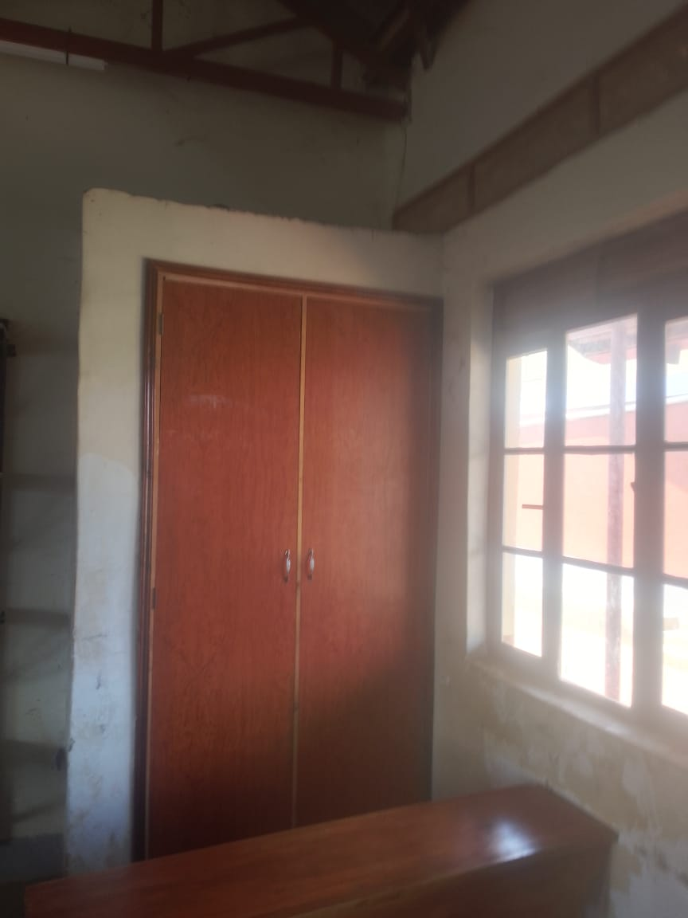
A SAMPLE OF UN ENGRAVED LIBRARY TABLES | 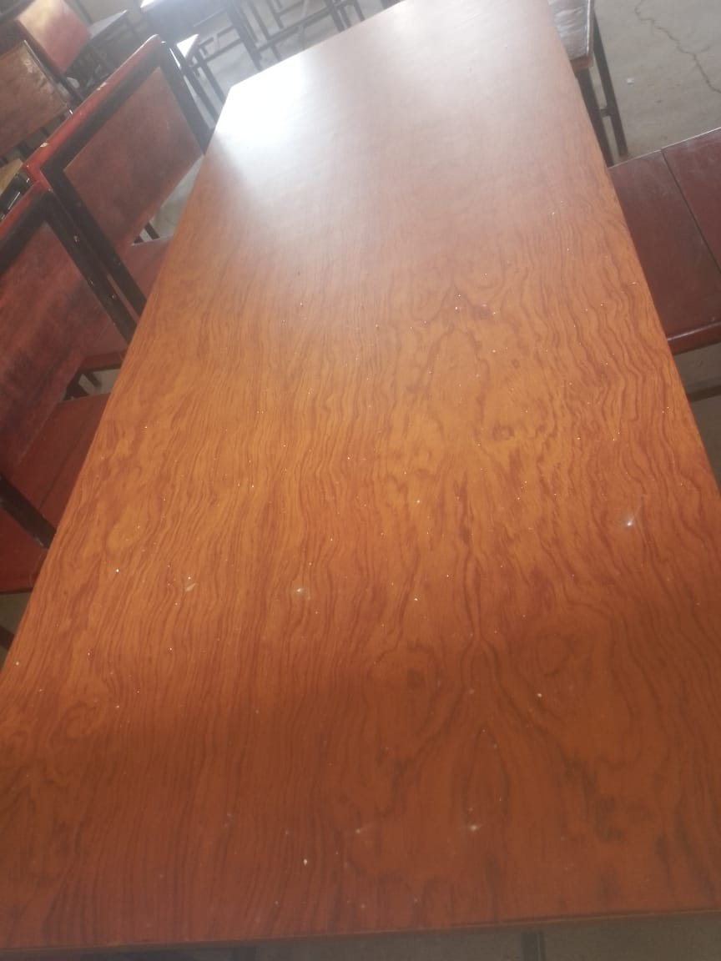
/  WALL MOUNTED SHELVES IN EACH OF THE CLASSROOMS | 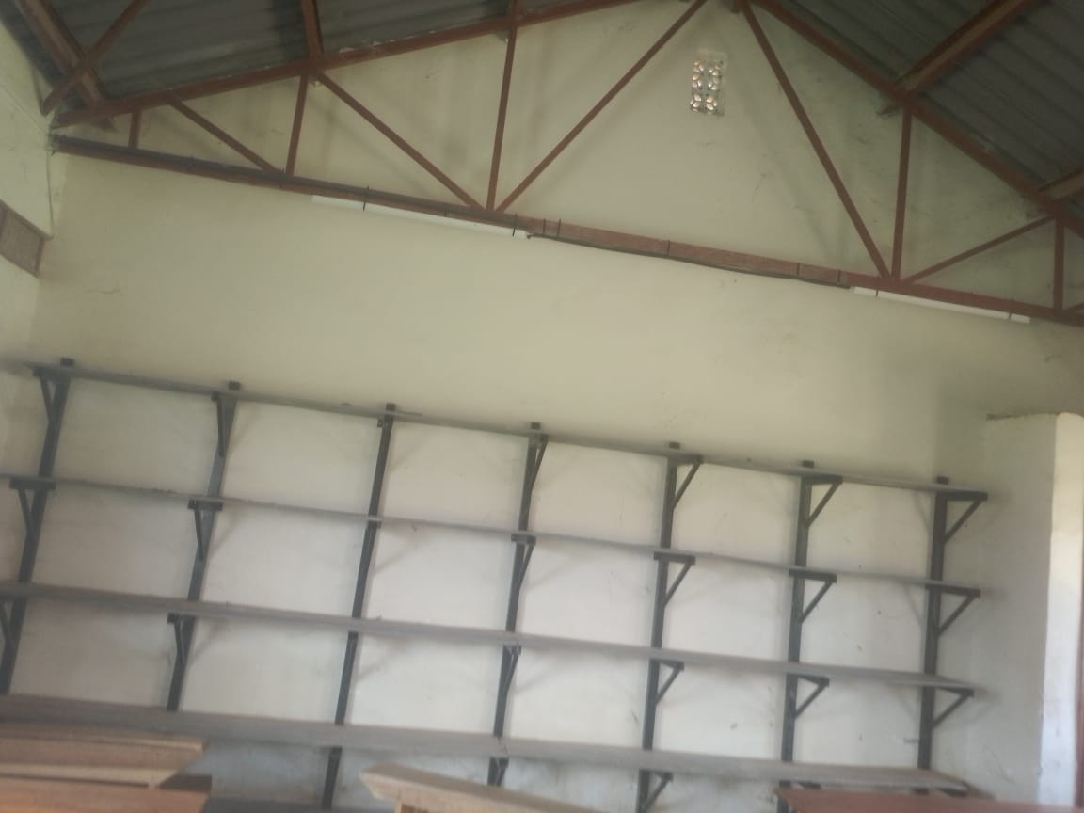
RECEIPTION TABLE ENGRAVED  “WAIRASA SEED SECONDARY SCHOOL” | 